Nov. 28, 2016

President-elect Donald J. Trump
Trump Tower
735 5th Avenue
New York, N.Y., 10022

Dear President-elect Trump,

Congratulations on being elected the 45th President of the United States of America and bringing a real focus on business and economic success to the White House.

As leaders of Arizona’s business community, the Greater Phoenix Chamber of Commerce shares your determination to restart our country’s economic engine via evaluating all government operations through a lens of increasing efficiency, removing regulatory barriers and best positioning businesses and entrepreneurs for success.

During recent meetings in Washington, D.C. with the U.S. Chamber of Commerce, members of Arizona’s congressional delegation and Scott Mason of your transition team, a coalition of Chamber and Arizona business leaders developed the following policy requests for your consideration that reflect the hopes and concerns of the Arizona business community.
- Trade/NAFTA: Free trade with Mexico is vital to Arizona’s economy and we respectfully request that any renegotiation of NAFTA considers that Mexico is Arizona’s #1 trading partner, with $41.6 billion worth of goods in two-way trade processed by Arizona’s six ports of entry in 2014. These figures are projected to rise in the coming years as Mexico’s middle class grows. The country’s economy is projected to grow to the seventh largest by 2050. Further, we encourage you to engage in Pacific Rim trade agreement discussions, whether within or outside of TPP. The plethora of emerging Rim economies coupled with irreversible globalization demand a United States – Pacific Rim trade agreement that optimizes commerce between the regions.

- Regulatory Reform: We fully support your mission to evaluate and repeal many of the onerous regulations dictated by Obama appointee-led agencies. While the recent emergency injunction of the Labor Department’s overtime rule is welcome news, we advocate for elimination of that regulation and several others including EPA mandates such as the Waters of the U.S. and Clean Power Plant rules. Upcoming key appointments of leaders at the Department of Labor, NLRB, EPA, Ex/Im Bank and, of course, the U.S. Supreme Court, are critical to restoring balance and equity in business, employment, environmental and other obligations.

- Federal Budget: We cannot over-emphasize our level of concern over the inaction on entitlement spending, which consumes currently 70 percent of the federal budget. We fully support your administration taking bold, historic action on this highly divisive issue, which will consume more than 90 percent of the federal budget by 2025 and threatens the long-term sustainability and vitality of the American economy. The future of the country we leave our children depends on taking action on this titanic issue.

- Infrastructure: We applaud your bold plan for a significant investment in our country’s aging infrastructure, because nothing less than bold action and strong leadership will produce the required capital for this monumental undertaking. Arizona business leaders have identified several funding options including increasing the gas tax and/or a general use tax which will provide immediate and long-term sustainable funding options for this vital initiative. Key to any infrastructure investment plan, especially in Arizona, is to expand and optimize our ports-of-entry with Mexico and the roads leading there to maintain and increase constructive commerce between our countries.

- Tax Reform: Healthy economies thrive on fair and balanced tax policies. As a successful businessman, we certainly don’t need to recite to you all the negative consequence caused by an overly burdensome corporate tax rate. The competitiveness of American businesses will be vastly increased by improving our relative position in the corporate tax environment, ensuring investment and jobs stay in the United States, where they belong.

- National Defense: We applaud your plan to fully repeal the defense sequester and submit a new budget to rebuild our depleted military. Providing the military with the adequate number of soldiers and equipment required to complete current missions is of paramount importance.

- Immigration: We request that your administration considers a guest worker program. Immigrant labor, when properly vetted and background checked, supports and helps grow the U.S. economy. Immigrant labor contributes to payroll and Social Security taxes and is essential to the economic vitality of border states, including Arizona.

As our 45th president, we know much is being asked of you as you create your full policy agenda and fill top posts in your administration. We genuinely appreciate your time in reviewing our requests and wish you continued success as you lead our country toward economic success.

We encourage you to contact us to discuss these issues or any priorities that Arizona’s business community can assist your administration in achieving.

Sincerely,

Todd Sanders  President & CEO  Greater Phoenix Chamber of Commerce  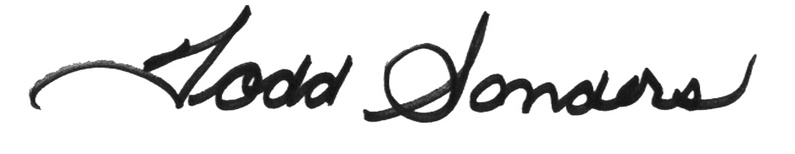 | Mike Huckins  Vice President, Public Affairs  Greater Phoenix Chamber of Commerce  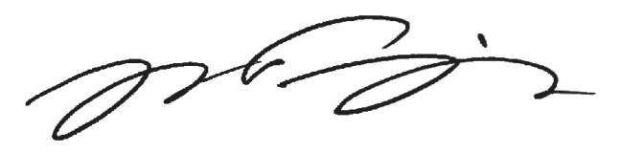
Jaime A. Molera  Partner  Molera Alvarez  GPCC Public Affairs Chairman  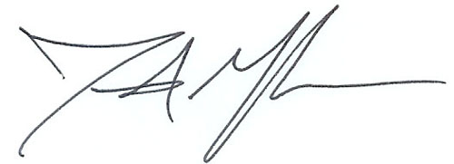 | Daniel Froetscher  Senior Vice President, Transmission, Distribution & Customers, APS  GPCC Chairman of the Board  